**PROJECT 2**

TEST CASES & RESULTS

Billy Kong

**Testing connection to the SQL database**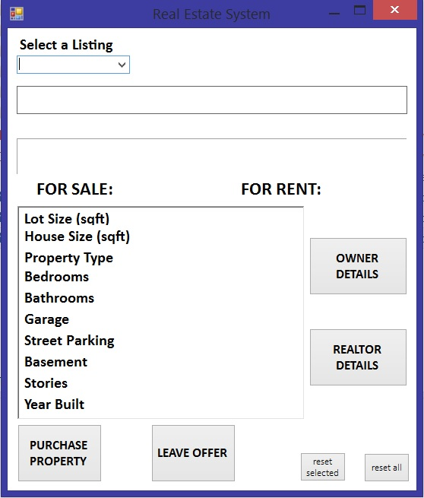

Result: Pass, connection failed error prompt did not appear, listings added

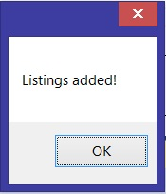

**Testing listings added to ComboBox**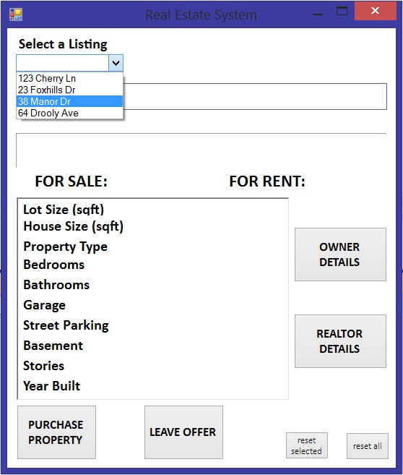

Result: Pass, sample listings have been successfully added (database listings incomplete)

**Testing information labels**

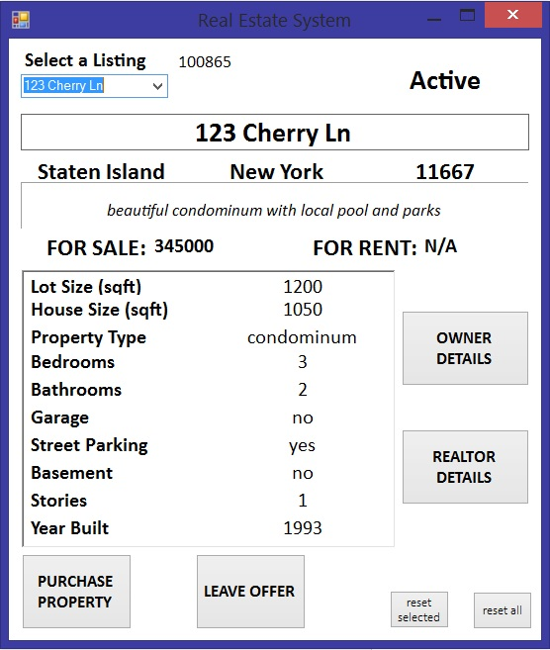

Result: Pass, information has been displayed on labels accordingly

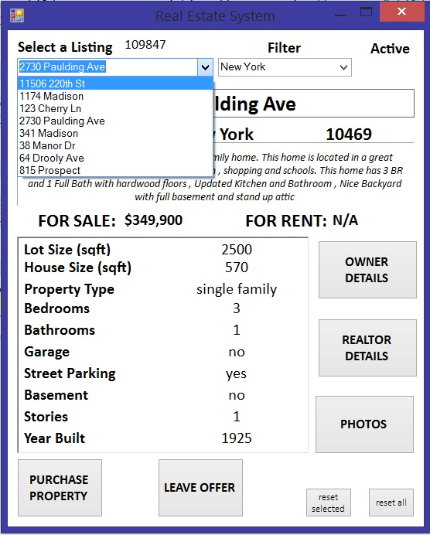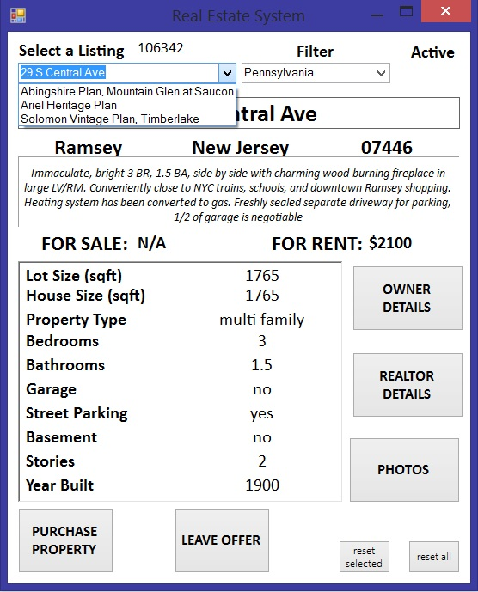

**Testing Filter of states New York and Pennsylvania**

Result: Pass, listings are successfully filtered by state

**Testing button click of “PURCHASE PROPERTY**

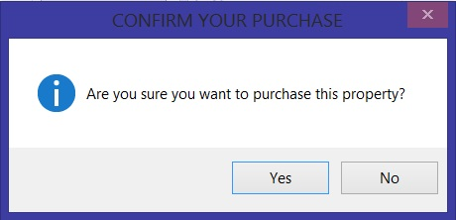

After clicking “SUBMIT”

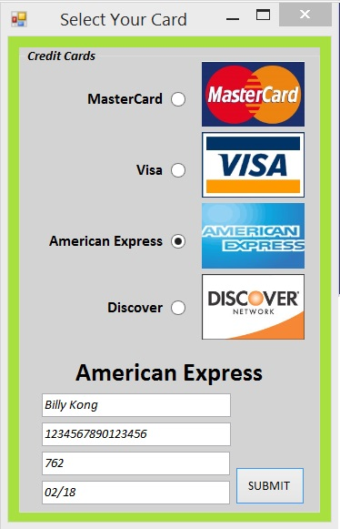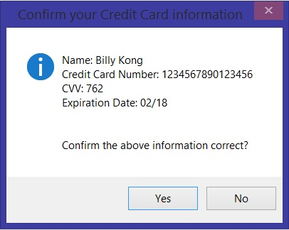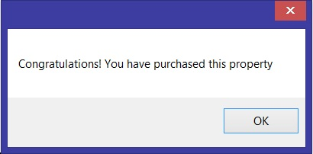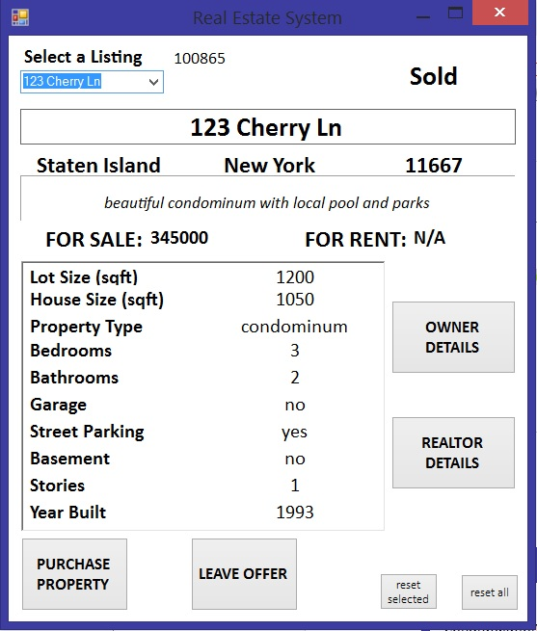

Result: Pass, prompts have been displayed accordingly, status (top right) of GUI has been successfully changed from ‘Active’ to ‘Sold’

**Testing button click of “LEAVE OFFER”**

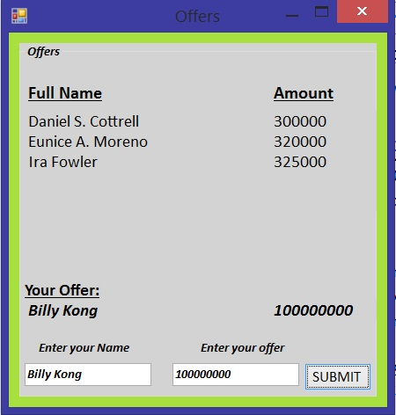

Result: Pass, names and offers are displayed properly, submitting your own offer works properly, your name and offers will be stored into the database

**Testing button click of “OWNER DETAILS”**

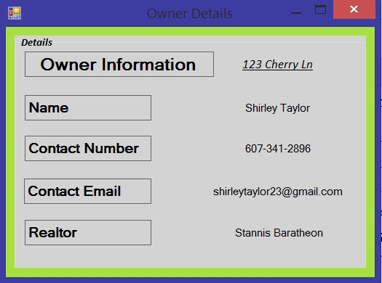

Result: Pass, labels display information accordingly

**Testing button click of “REALTOR DETAILS”**

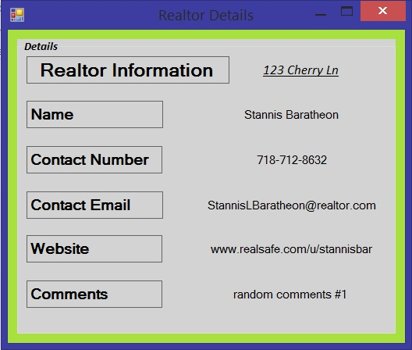

Results: Pass, Information is displayed as should

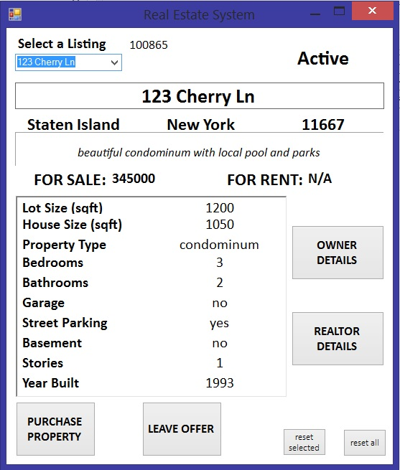

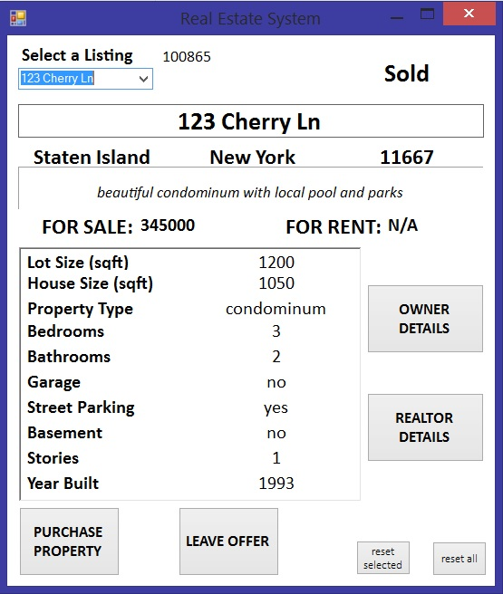

**Testing button click of “reset selected”**

Result: Pass, Sold has been reset to Active

**Testing button click of “reset all”**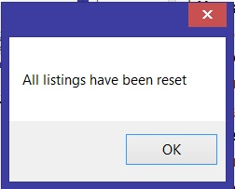

Result: Pass, MessageBox prompting that all listings have been reset appeared

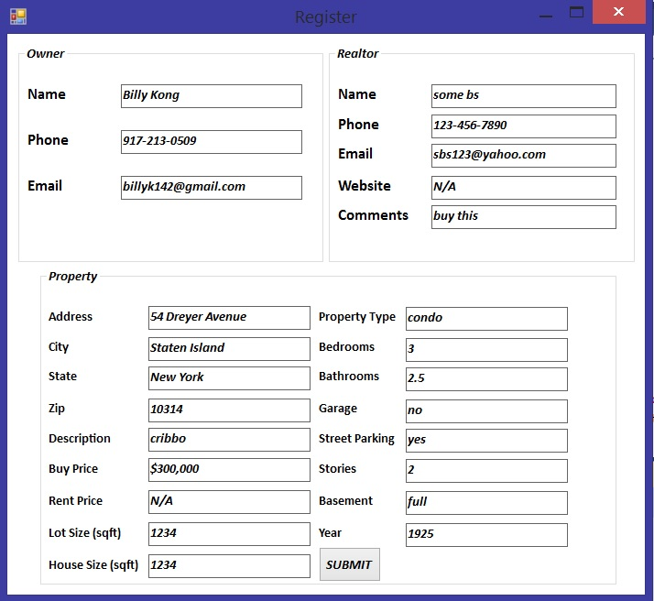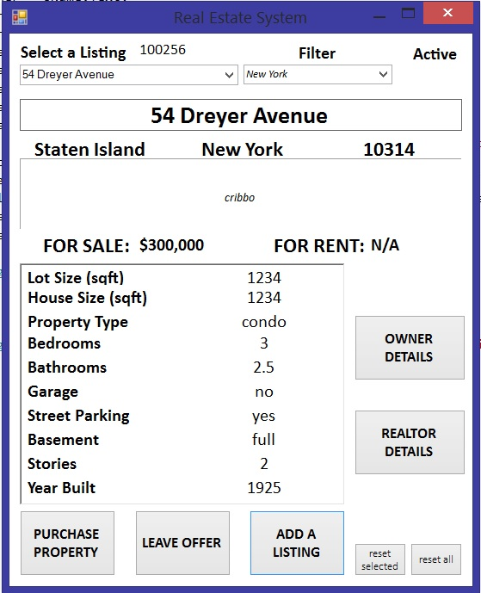

**Testing functionality of “ADD A LISTING”**

Result: Pass, Listing is added and displays correct information